
Software Requirement Specification (SRS)
Project Name: Hospital Appointment Management System.

Date: October 27, 2025.

Version: 1

Team Members:
- Hiba Sabbagh (1123027)
- Nay Hamdan (1123122)
- Fatima Dorra(1123222)
Table of Contents
1- Introduction 3
1.1- SDLC Model 3
1.2- Product Scope 4
1.3- Product Value 4
1.4-Intended Audience 4
1.5- Intended Use 5
1.6- General Description 5
1.7-Feasibility Study 6
1.8- Functional Requirements 7
1.9- External Interface Requirements 8
1.10- Nonfunctional Requirements 9
1.11- Definitions and Acronyms 10
2- Diagrams 11
2.1- Class Diagram 11
2.2- Activity Diagram 12
2.3- Use Case Diagram 13
2.4- Data Flow Diagram 14
3-Charts 17
3.1-Pert Chart 17
3.2- Gant Chart 19

1- Introduction

1.1 SDLC Model:
For developing the Hospital Appointment Management System (HAMS), we chose the Waterfall Model.
This model fits our project because all the requirements were clearly defined before we started coding. We knew exactly what the system needed to include managing patients, doctors, and appointments and we didn’t expect major changes along the way.
The Waterfall approach allowed us to move through each phase planning, design, implementation, and testing in a structured and organized manner. This made it easier to stay on schedule and maintain quality at every step.

1.2- Product scope: The Hospital Appointment Management System is designed to digitize and simplify the appointment process in hospitals and clinics.

It allows patients to easily book or cancel appointments, while giving doctors and administrators a clear view of daily schedules. The system reduces paperwork, minimizes human error, and improves communication between hospital staff and patients.

In short, HAMS helps hospitals provide faster, more organized, and more reliable healthcare services.

1.3- Product value:

Hospital appointment system adds value by improving both efficiency and patient experience:

• It saves time for hospital staff by automating scheduling and record management.

• It helps doctors stay organized by displaying their upcoming appointments and patient details.

• It makes the booking process simple and accessible for patients, even without technical knowledge.

By reducing manual effort and preventing scheduling conflicts, the system ensures a smoother workflow for the entire hospital.

1.4- Intended audience:

This project is designed for:

• Hospital administrators who manage staff and appointments

• Doctors and nurses who view their daily schedules and records

• Receptionists who handle patient bookings

Patients who need to make or manage appointments

1.5- Intended use:
Hospital appointment system can be used in hospitals, clinics, and medical centers of any size.
It helps:
• Administrators manage doctors and appointments efficiently
• Doctors review and update their patient visits
• Patients easily schedule or cancel their appointments
Its main goal is to create a simple, fast, and reliable appointment management process.
1.6- General description:
The system provides an easy to use dashboard that includes:
- Patient Management: Add, edit, or remove patient profiles
- Doctor Management: Manage doctor details and availability.

Appointment Management: Book, cancel, or update appointments

Reports: View daily or weekly statistics on patient visits and doctor schedules

1.7-Feasibility Study

Technical Feasibility:

The system is developed using Java 22 in NetBeans IDE. It can run on any computer that supports Java and doesn’t need a special setup or internet connection. All tools used are free and widely available, so the project is completely achievable from a technical point of view.

Legal Feasibility:

Hospital appointement system follows legal and ethical standards. All patient and doctor information is stored securely and privately in local .data files. No personal or medical data is shared with anyone outside the system. All used software tools are open-source and legally licensed.

Operational Feasibility:

The system is simple to use, even for non-technical hospital staff. The graphical interface is clear and easy to navigate, so tasks like booking appointments or adding new patients can be done quickly.

Training new users would take very little time, making it practical for daily hospital operations

Scheduling Feasibility:
The development followed a tight schedule, completed within one week. We used the Waterfall model to organize work into clear stages: planning, design, implementation, and testing Because this was a course project, all tools were free, and no financial cost was required
1.8-Functional requirements:
1.Patient Management
- Add a new patient (name, age, phone number, address, gender).
- View patient information and appointment history.
- Edit or remove patient details when needed.
2. Doctor Management
- Add new doctors (name, specialty, phone number, available days).
- View and update doctor profiles.
- Remove doctors who are no longer active

3. Appointment Management:
- Book a new appointment (select patient, doctor, date, and time).
- Cancel or reschedule an existing appointment.
- View upcoming or past appointments for any patient or doctor
4. Reports and Statistics:

Generate summaries of appointments by day, week, or doctor.

View total number of patients and bookings

1.9-External interface requirements:

User Interface Requirement:

The interface is designed with simplicity in mind. It uses clean layouts, readable fonts, and calm hospital colors like light blue and white.

Navigation is straightforward users can move between the main sections (Patients, Doctors, Appointments, Reports) easily through buttons and menus.

Hardware interface requirements
Hospital appointment system can run on any standard computer (Windows, macOS, or Linux). It doesn’t need special hardware or an internet connection.
- Software Interface Requirement

Built entirely in Java, using NetBeans as the development environment. Data is stored in data files using Java’s file handling features. The interface is based on Java’s built-in GUI components.

Communication interface requirements
Hospital appointment system works as a standalone system. The different parts of the program (like Patient, Doctor, and Appointment classes) communicate internally through Java objects and methods. This ensures secure and efficient data transfer inside the application

1.10-Non-functional requirements

Security:

All stored data is protected and accessible only through the system. Sensitive patient information is handled carefully to maintain privacy.

Capacity:

The system can manage hundreds of patients and appointments without slowing down

Compatibility:

Works on major operating systems (Windows, macOS, Linux).

Reliability:

Ensures that data is safely stored and retrieved every time the system is used

Scalability
The system Can be easily expanded to include more doctors, departments, or online booking features in the future.

Maintainability:

Because it’s built using object-oriented programming, each part of the system can be modified or improved without affecting the rest.

Usability:
The system’s design focuses on simplicity. Even users with basic computer knowledge can operate it easily after a short introduction.

1.11- Definitions and acronyms:
- CRUD:Create, Read, Update, Delete
- GUI: Graphical User Interface
- IDE: Integrated Development Environment
- OOp:Object-Oriented Programming
- Data: File A local data file used to store system

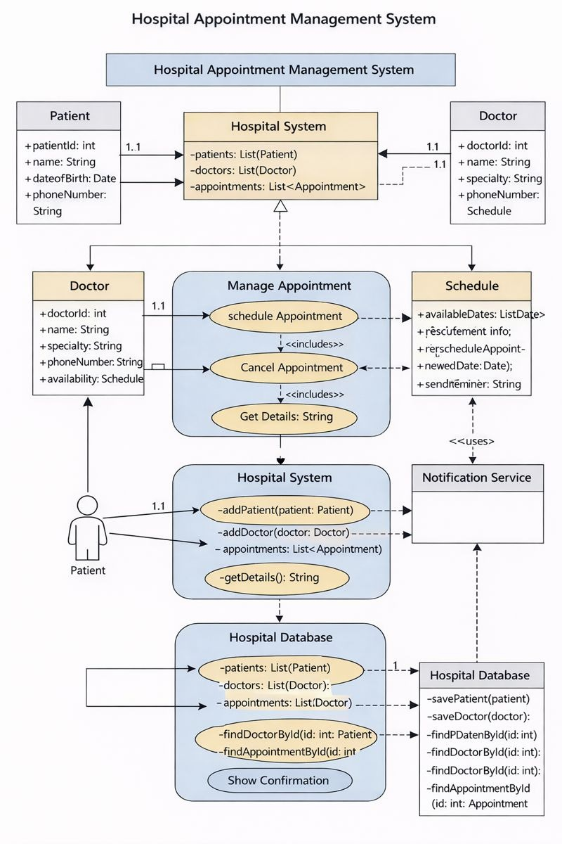
2- Diagrams
2.1-Class Diagram
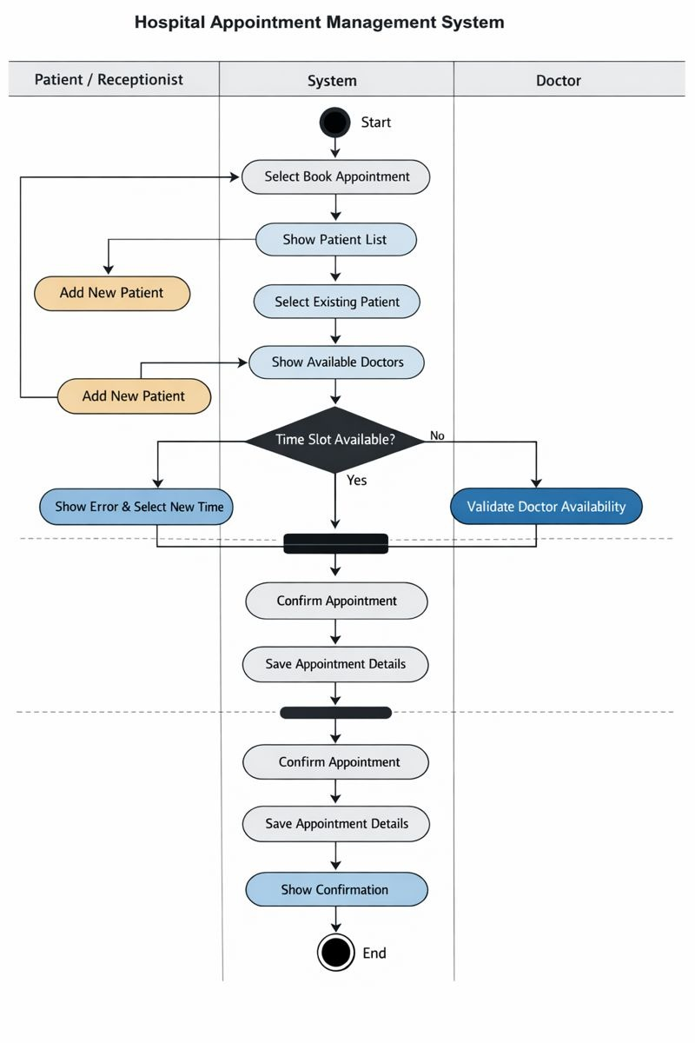
2.2 Activity Diagram
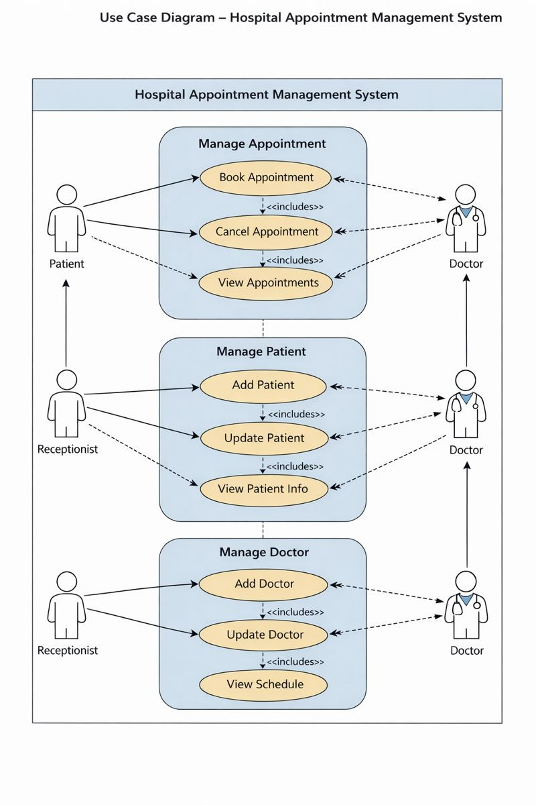
2.3- Use Case Diagram
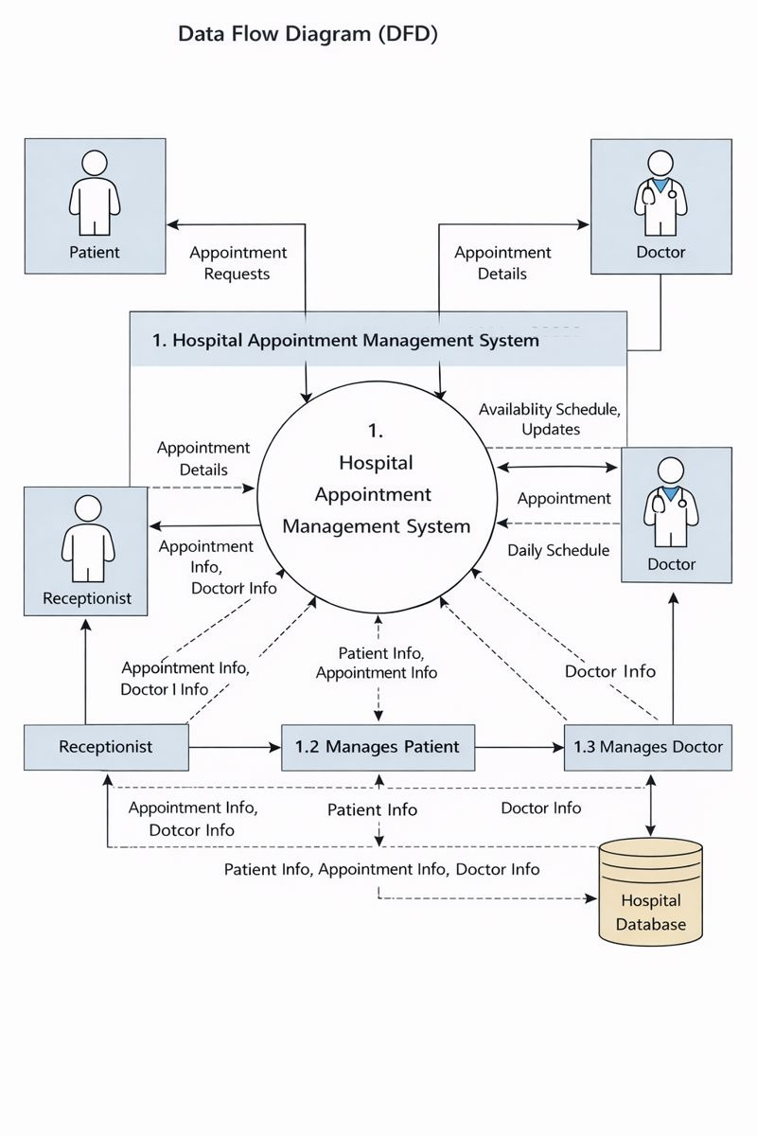
2.4- Data Flow Diagram

3- Chart
- Functional Requirements Breakdown :
1-Patient Management
1.1. Design patient registration interface (Add Patient) (1–2 days): task 1
- Input fields for name, age, gender, phone number, and address
1.2. Implement patient data validation and storage (2–3 days): task 2
- Validate required fields
- Store patient data securely in system files
1.3. Develop patient information viewing functionality (1–2 days): task 3
- Display patient details
- Display appointment history
1.4. Implement patient update and deletion features (1–2 days): task 4
- Edit patient information
- Remove patient records when needed

2. Doctor Management
2.1. Design doctor registration interface (1–2 days): task 5
- Input doctor name, specialty, phone number, and available days
2.2. Implement doctor data validation and storage (2–3 days): task 6
- Validate entered doctor data
- Save doctor profiles
2.3. Develop doctor profile viewing functionality (1–2 days): task 7
- Display doctor details
- Display availability schedule
2.4. Implement doctor update and removal features (1–2 days): task 8
- Update doctor information
- Remove inactive doctors

3. Appointment Management
3.1. Design appointment booking interface (2–3 days): task 9
- Select patient
- Select doctor
- Select date and time
3.2. Implement appointment booking logic and availability checking (3–4 days): task 10
- Check doctor availability
- Prevent scheduling conflicts
- Save appointment data
3.3. Develop appointment cancellation and rescheduling functionality (2–3 days): task 11
- Cancel existing appointments
- Update appointment date and time
3.4. Implement appointment viewing functionality (1–2 days): task 12
- View upcoming appointments
- View past appointments
- Filter by patient or doctor

4. Reports and Statistics
4.1. Design reports interface (1–2 days): task 13
- Simple and clear report layout
4.2. Implement appointment summary reports (2–3 days): task 14
- Daily appointment reports
- Weekly appointment reports
4.3. Develop statistical views for system data (1–2 days): task 15
- Total number of patients
- Total number of appointments
- Doctor workload statistics

5. Data Handling and System Support
5.1. Implement secure data storage mechanism (2–3 days): task 16
- Store patient, doctor, and appointment data in local files
5.2. Develop data retrieval and system initialization logic (1–2 days): task 17
- Load saved data at system startup
- Ensure data consistency

- Task Management:
1-In patient Management Tasks:
- Task 1 → Task 2
(Patient interface must be completed before validation and storage)
- Task 2 → Task 3
(Patient data must be stored before viewing information)
- Task 3 → Task 4
(Patient information must exist before update/delete operations)
2-In Doctor Management Tasks:
- Task 5 → Task 6
(Doctor interface must be completed before data storage)
- Task 5 → Task 7
(Doctor must be registered before viewing profile)
- Task 6 → Task 7
(Doctor data must be stored before viewing profile)

3-In Appointment Management Tasks:
- Task 8 → Task 9
(Appointment booking interface must be completed before implementing booking logic)
- Task 9 → Task 10
(Booking logic must exist before admin can manage bookings)
- Task 10 → Task 11
(Appointment must exist before cancel/reschedule functionality)

4 – In Reports and Statistics Tasks:
- Task 12 → Task 13
(Appointment viewing must be completed before reports interface)
- Task 12 → Task 14
(Appointment data must exist before generating reports)
- Task 13 → Task 15
(Reports interface must be ready before statistics dashboard)
- Task 14 → Task 15
(Reports data feeds the statistics dashboard)
5- Data Handling Tasks:
- Task 16 → Task 17
(Data storage must exist before retrieval logic)
- Task 16 → Task 18
(Data storage must exist before system initialization and consistency check

3-Chart
3.1-PertChart
End

T16

T17

T4

T10

T1

Start
T2

T9

T3

T12

T11

T7

T6

T5

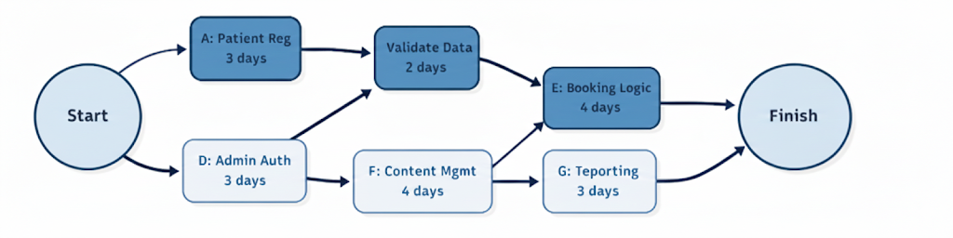
T15

T13

T14

T8

ID  3.2-Gant Chart | Task Name | predecessor | Duration | Start  Date | End Date | ES | EF | LS | LF | Slack | Critical
T1 | Patient Registration interface | - | 2 days | Jan 16 | Jan 17 | 0 | 2 | 0 | 2 | 0 | YES
T2 | Patient validation and Storage | T1 | 3 days | Jan 18 | Jan 20 | 2 | 5 | 2 | 5 | 0 | YES
T3 | View Patient Information | T2 | 2 days | Jan 21 | Jan 22 | 5 | 7 | 6 | 8 | 1 | No
T4 | Update/delete patient | T2 | 2 days | Jan 23 | Jan 24 | 5 | 7 | 6 | 8 | 1 | No
T5 | Doctor Registration Interface | T1 | 2 days | Jan 25 | Jan  26 | 2 | 4 | 3 | 5 | 1 | No
T6 | Doctor validation and Storage | T5 | 3 days | Jan 27 | Jan  29 | 4 | 7 | 5 | 8 | 1 | No
T7 | View Doctor Profile | T6 | 2 days | Jan  30 | Jan 31 | 7 | 9 | 8 | 10 | 1 | No
T8 | Update/remove Doctor | T6 | 2 days | Feb 1 | Feb 2 | 7 | 9 | 8 | 10 | 1 | No
T9 | Appointment Booking Interface | T3,T7 | 3 days | Feb 3 | Feb 5 | 9 | 12 | 9 | 12 | 0 | yes
T10 | Booking Logic and Availability chick | T9 | 4 days | Feb 6 | Feb 9 | 12 | 16 | 12 | 16 | 0 | yes
T11 | Cancel/Reschedule Appointment | T10 | 3 days | Feb 10 | Feb 12 | 16 | 19 | 16 | 19 | 0 | yes
T12 | View Appointmnets | T10 | 2 days | Feb 13 | Feb 14 | 16 | 18 | 17 | 19 | 1 | No
T13 | Reports Interface | T12 | 2 days | Feb 15 | Feb 16 | 18 | 20 | 19 | 21 | 1 | No
T14 | Appointment Reports Generation | T13 | 3 days | Feb 17 | Feb 19 | 20 | 23 | 20 | 23 | 0 | yes
T15 | Statictics Dashbord | T14 | 2 days | Feb 20 | Feb 21 | 23 | 25 | 24 | 26 | 1 | No
T16 | Data Storage System | T2, T6 ,T10 | 3 days | Feb 22 | Feb 24 | 16 | 19 | 16 | 19 | 0 | yes
T17 | Data Retrieval and initialization | T16 | 2 days | Feb 25 | Feb 26 | 19 | 21 | 19 | 21 | 0 | yes

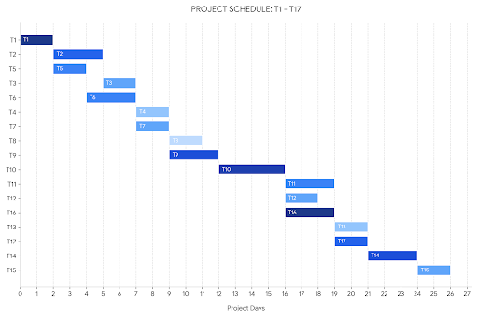
3.2-Gant Chart

4- Jira
- Fatima Dorra:
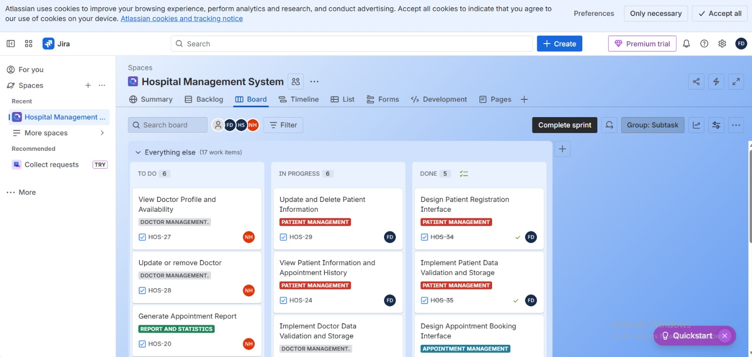
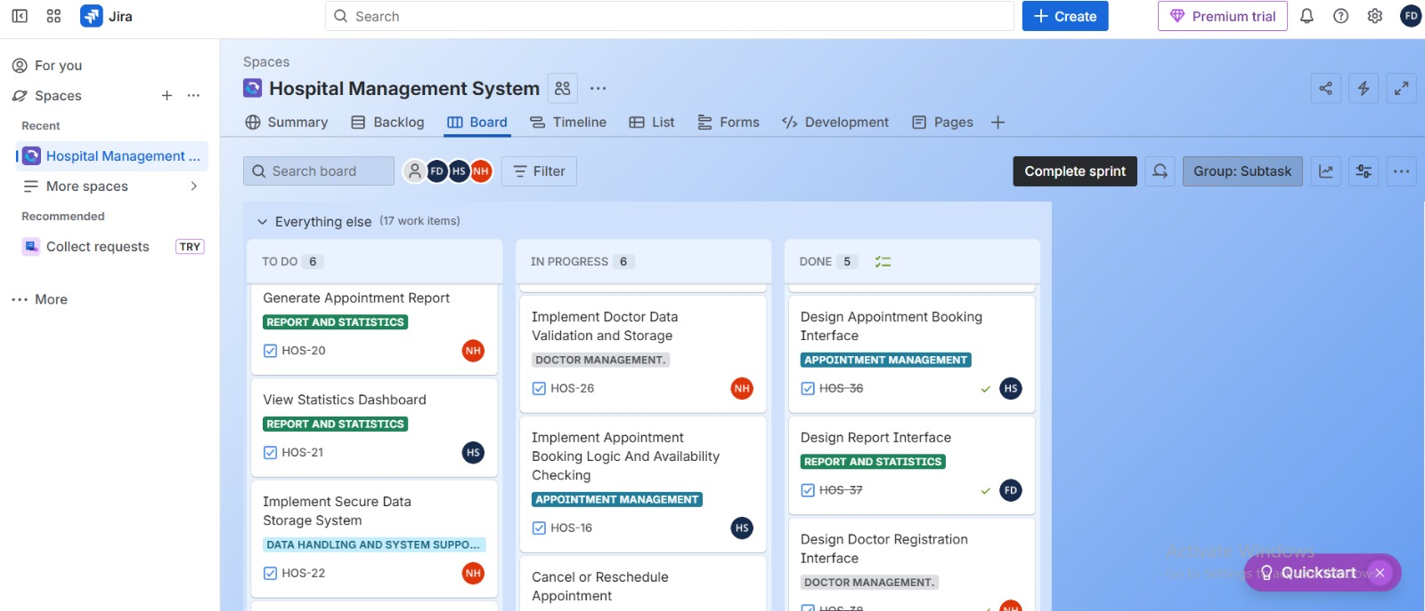
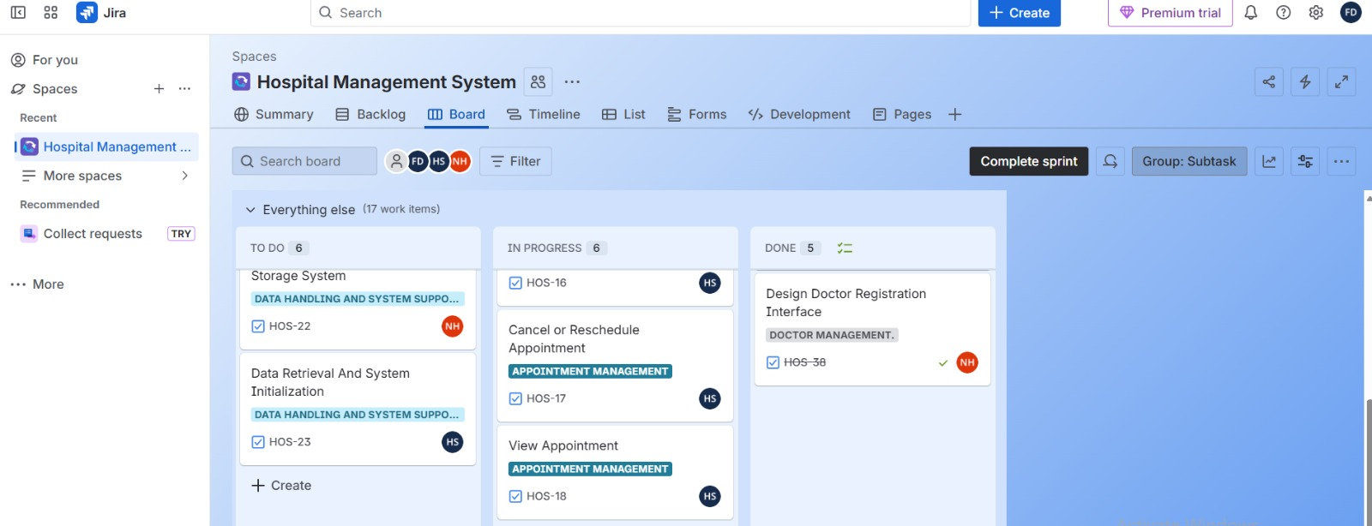

- Hiba Sabbagh:
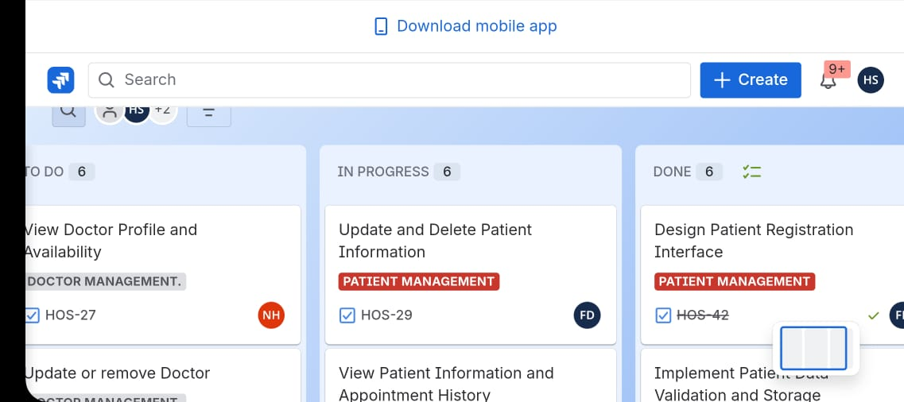
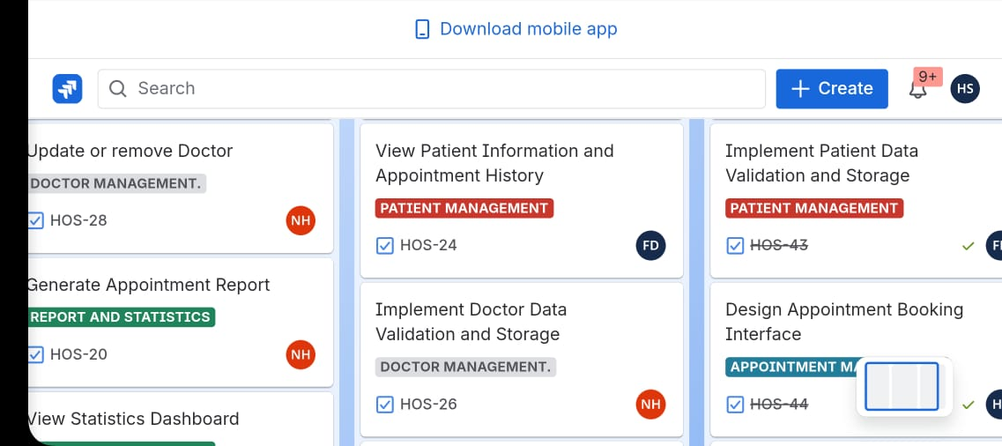
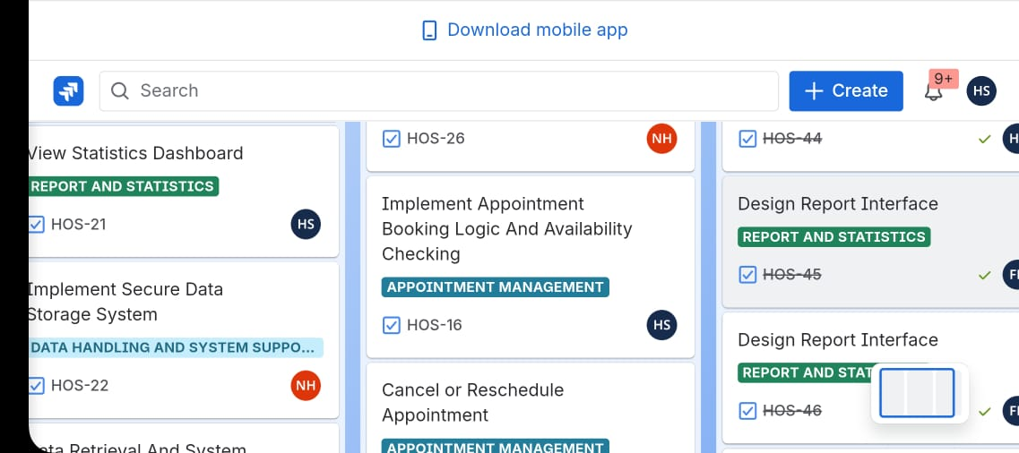

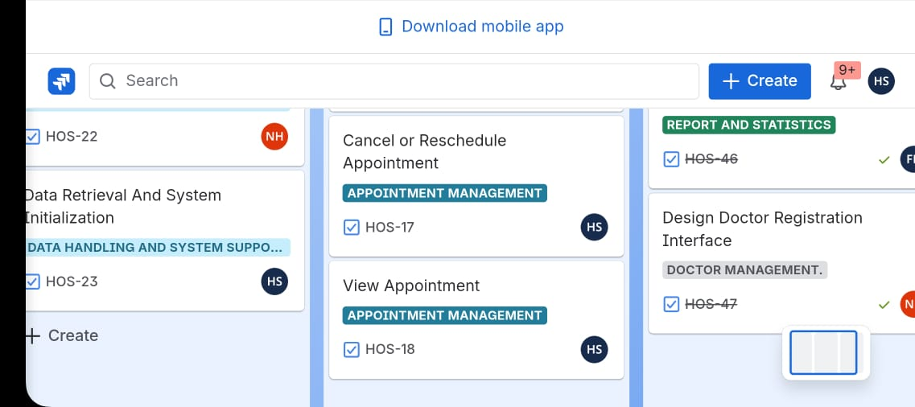

- Nay Hamden:
